Lissencephaly Vs Normal Brain Plus Normal Brain Anatomy

Images from LINE.17QQ.COM © 2010-2021 All Rights Reserved.

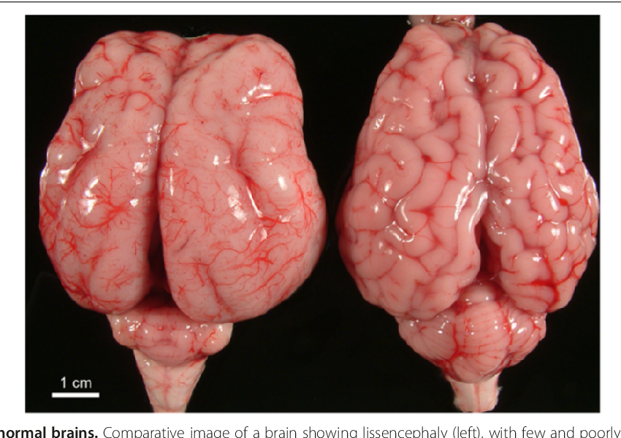
Lissencephaly Vs Normal Brain

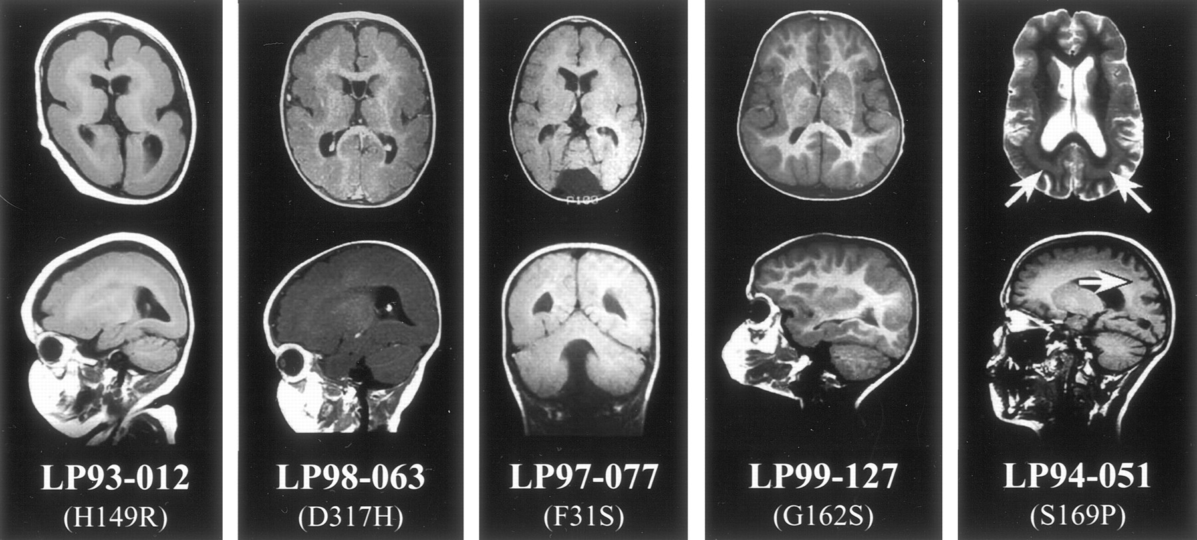
Lissencephaly Vs Normal Brain

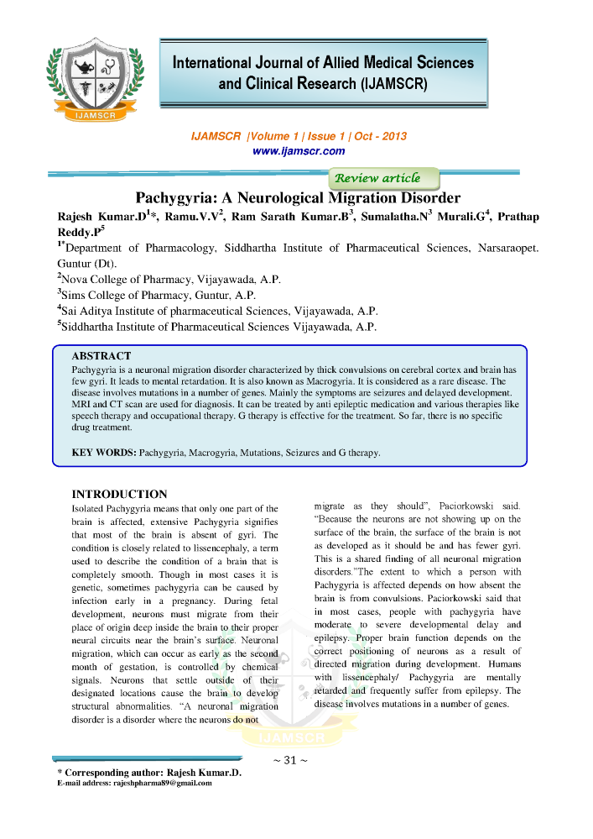
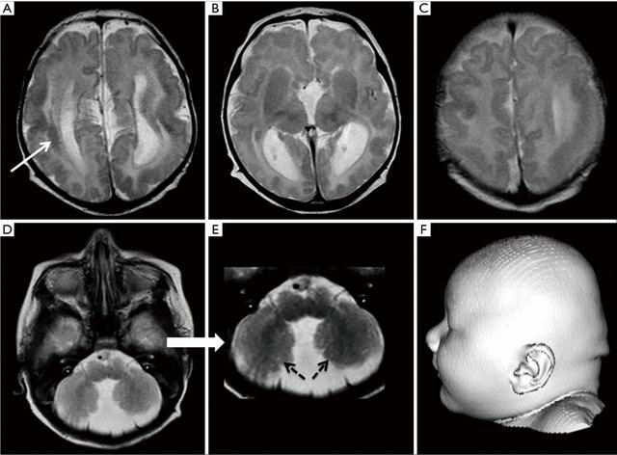
Lissencephaly Vs Normal Brain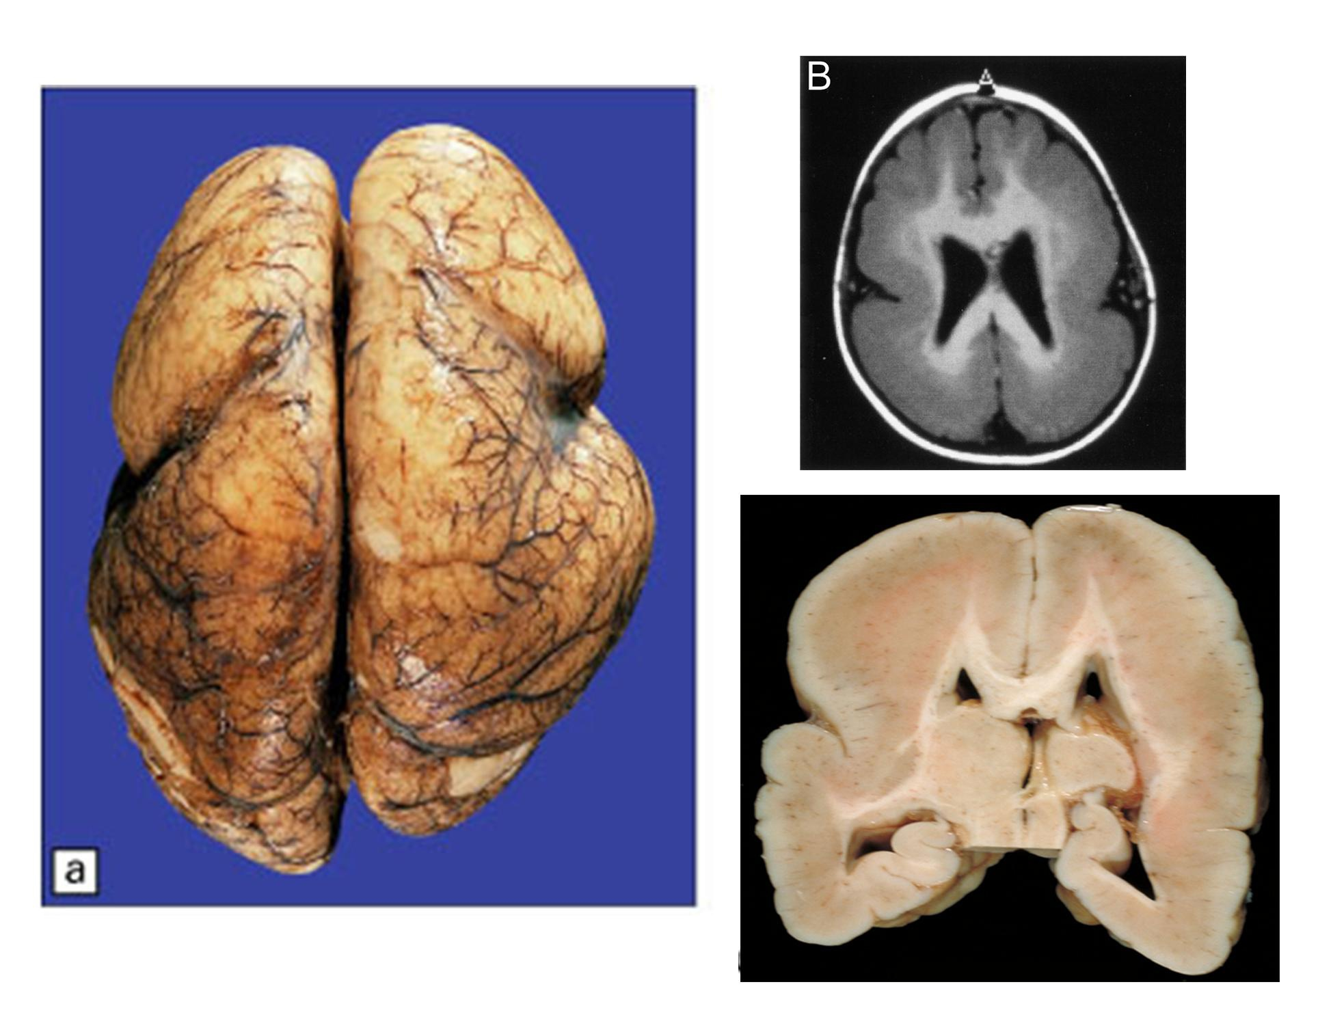
V. Developmental Pathology at Harvard University

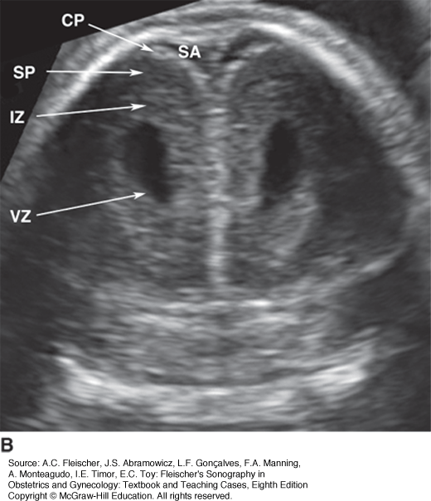
Ultrasound Detection of Chromosomal Anomalies, Congenital ...
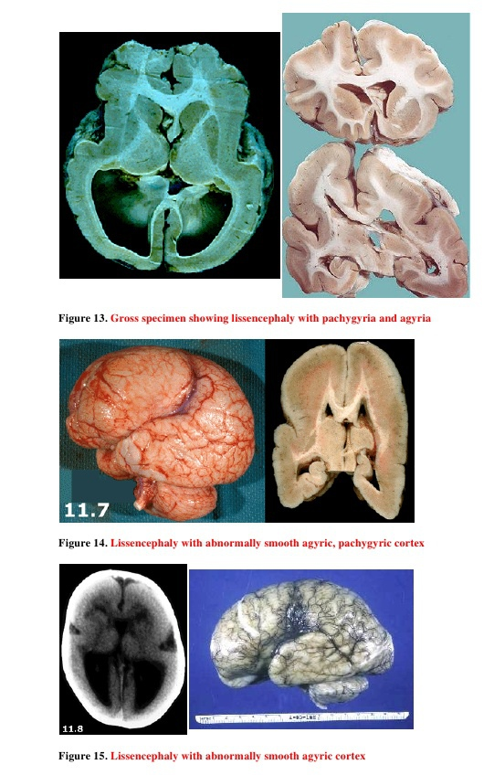
Case record...Cortical dysplasia

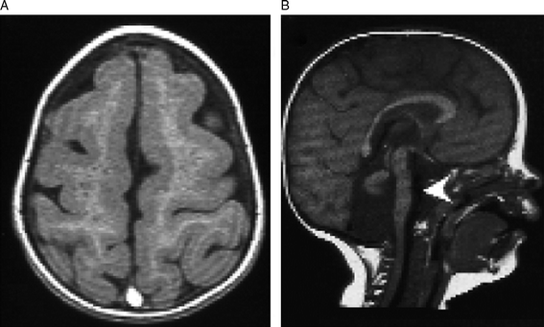
Lissencephaly Vs Normal Brain
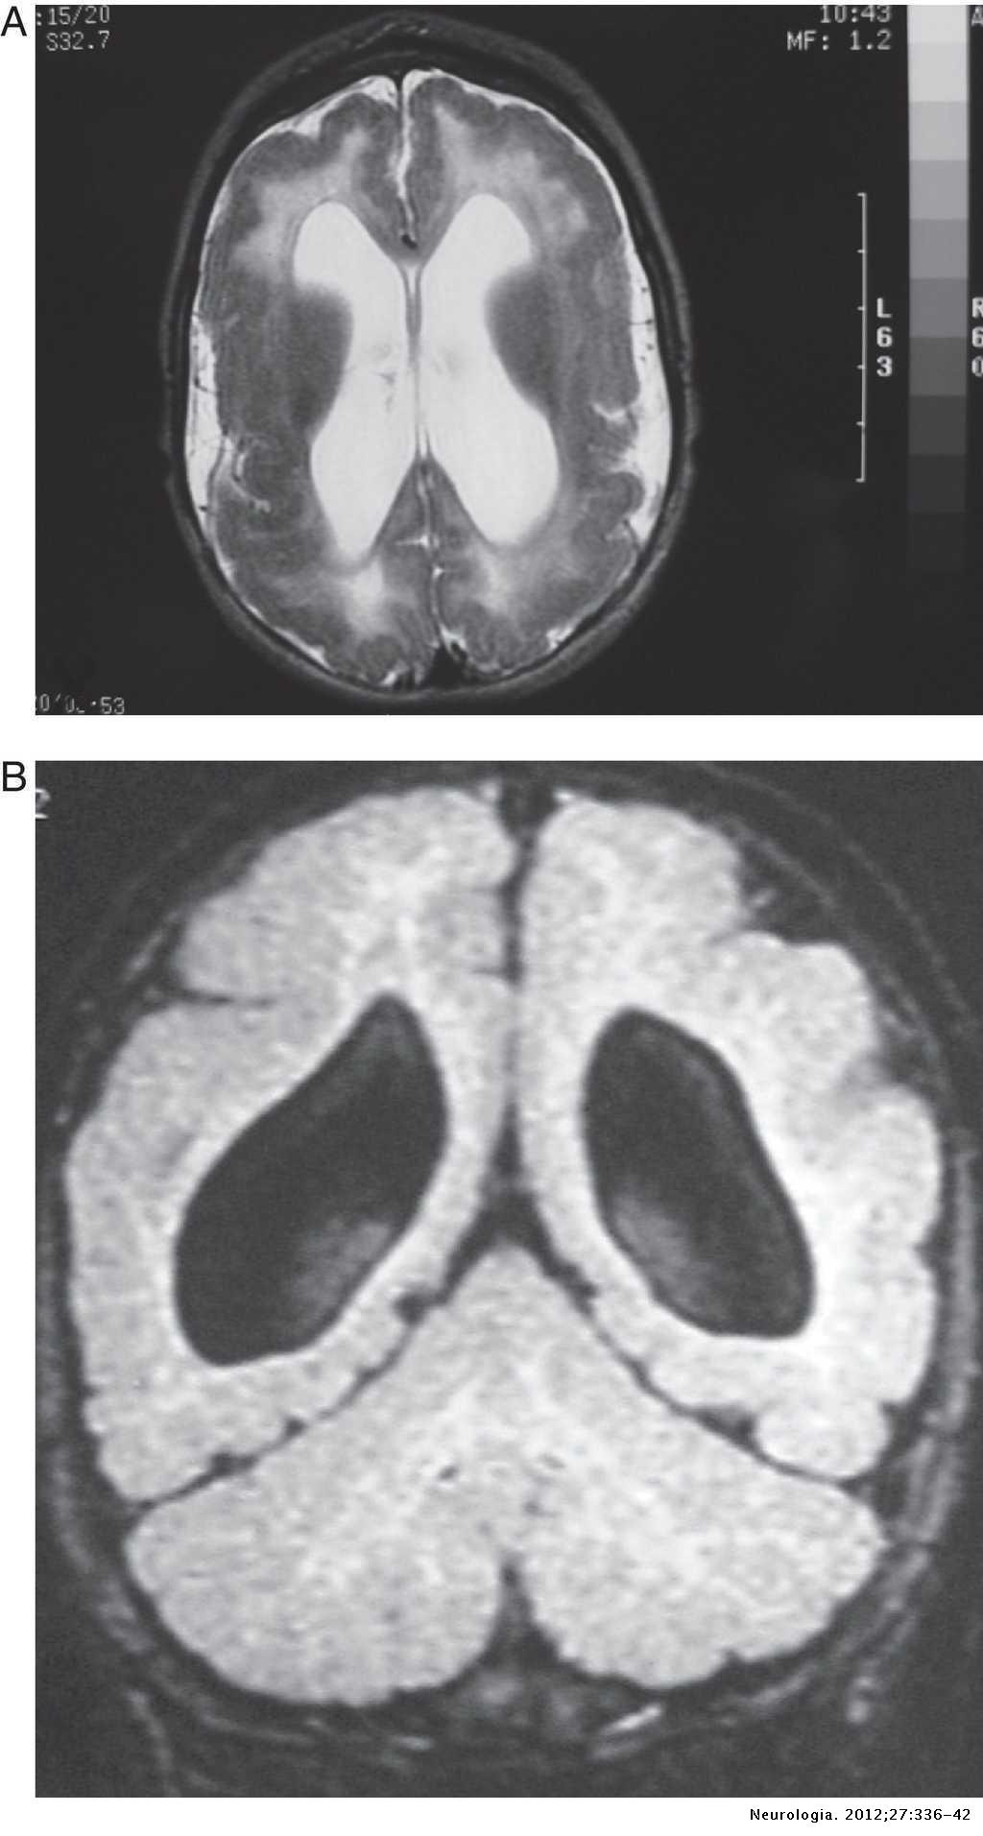
Congenital cytomegalovirus infection and cortical ...

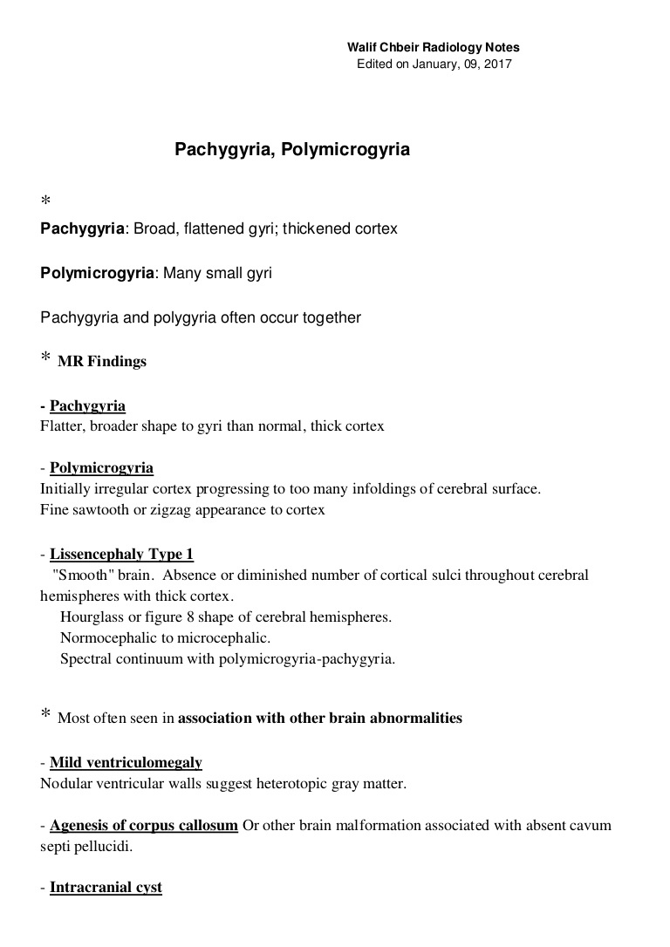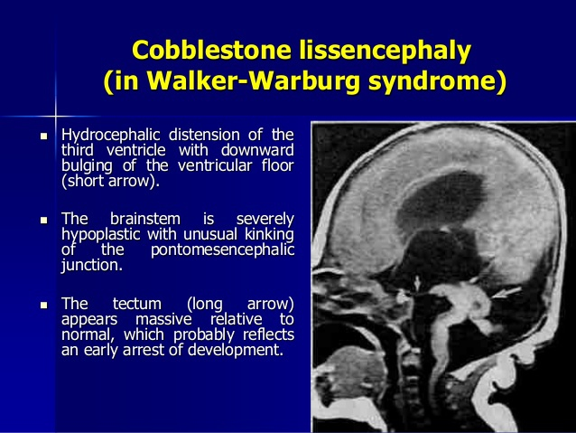
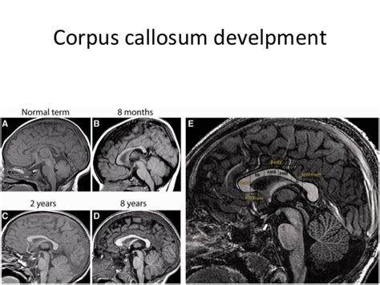

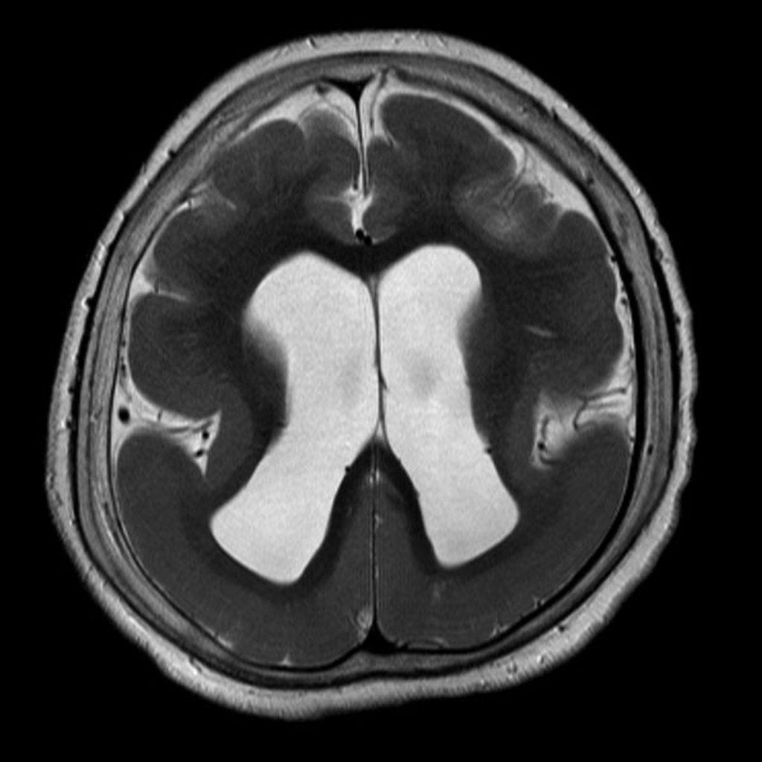
Pachygyria
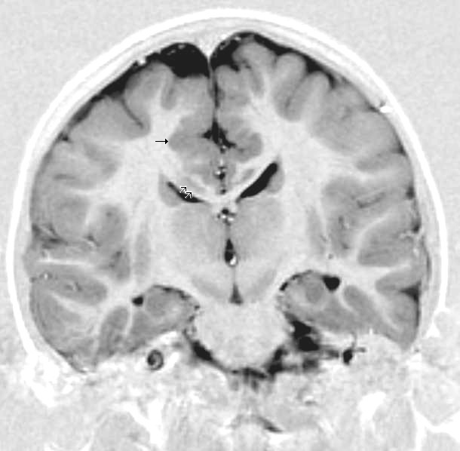
Cobblestone Lissencephaly; Cobblestone Complex ...

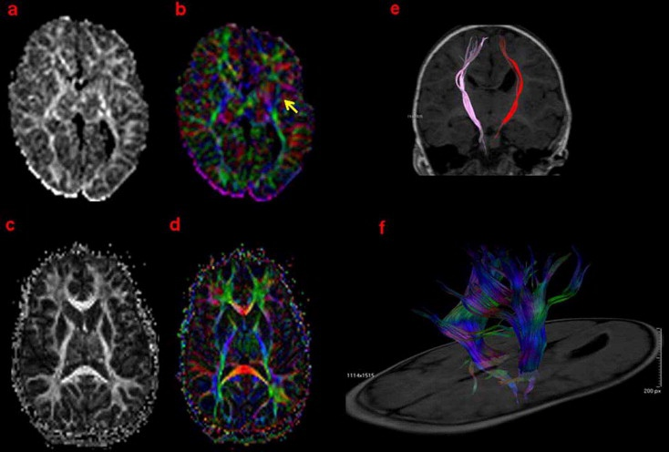
Description of a novel TUBA1A mutation in Arg-390 ...
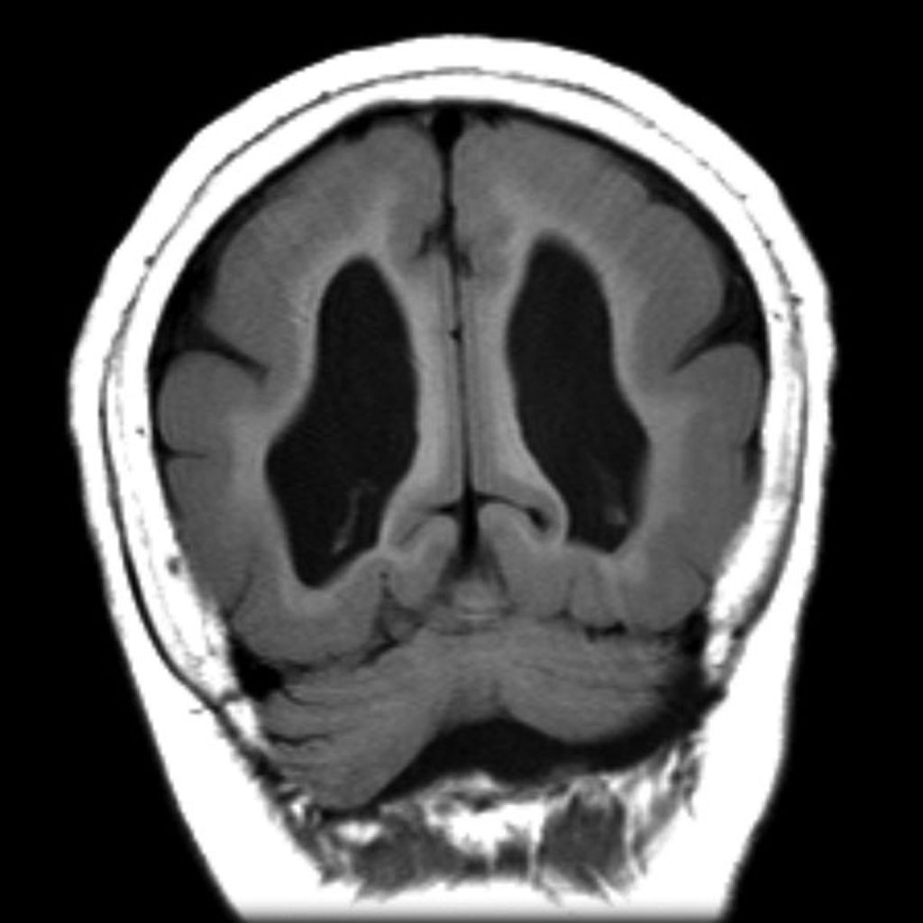 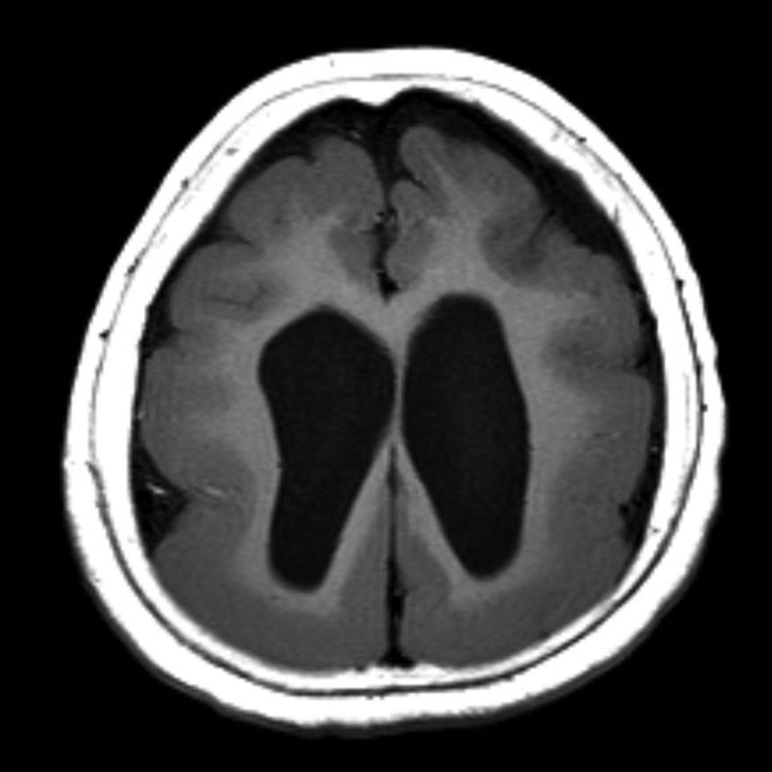 Pachygyria

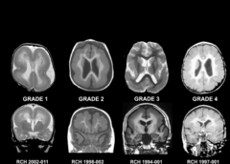
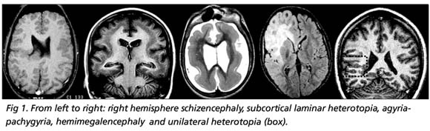
The clinical spectrum of malformations of cortical development
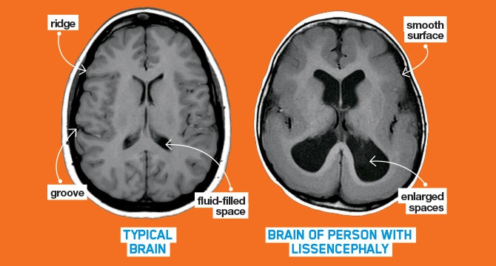
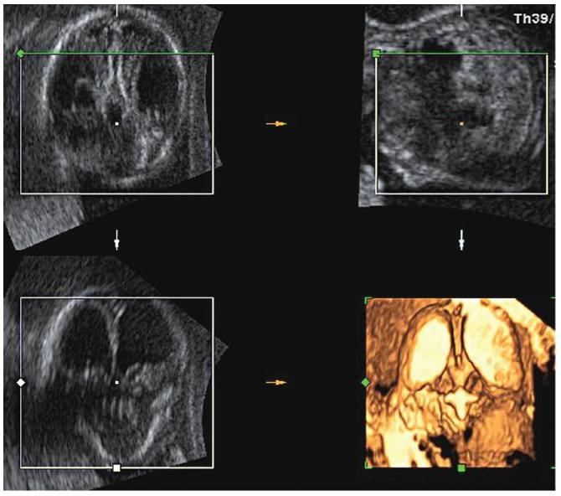
Prenatal Diagnosis of Lissencephaly Type 2 using Three ..

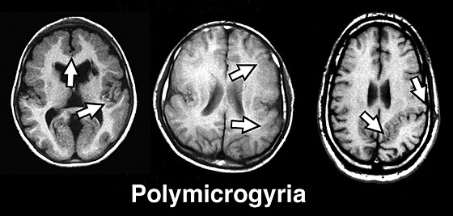
Symmetric polymicrogyria and pachygyria associated with TUBB2B gene mutations

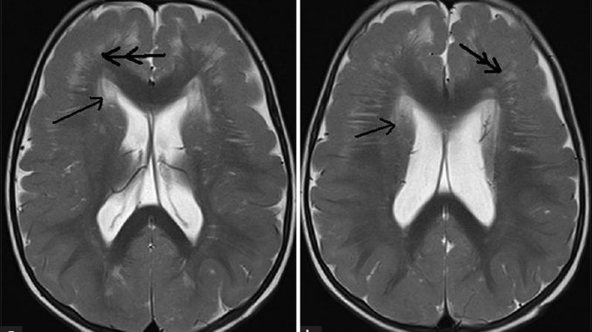
Technical Info on Pachygyria and Lissencephaly Levels ...

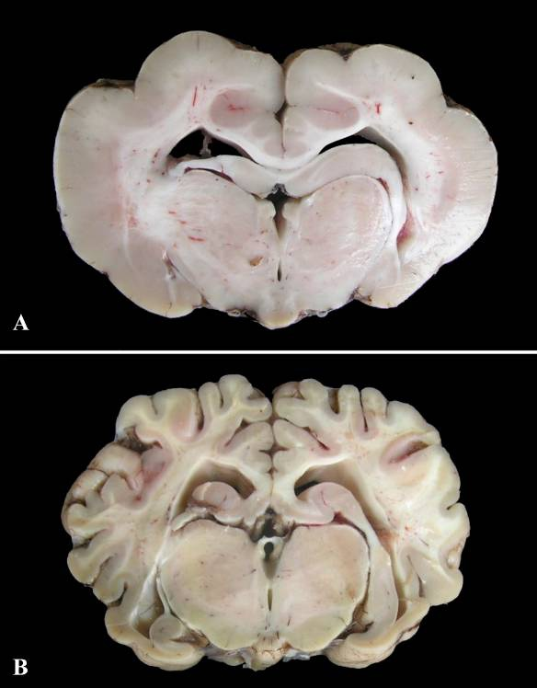
Lissencephaly-pachygyria and cerebellar hypoplasia in a calf

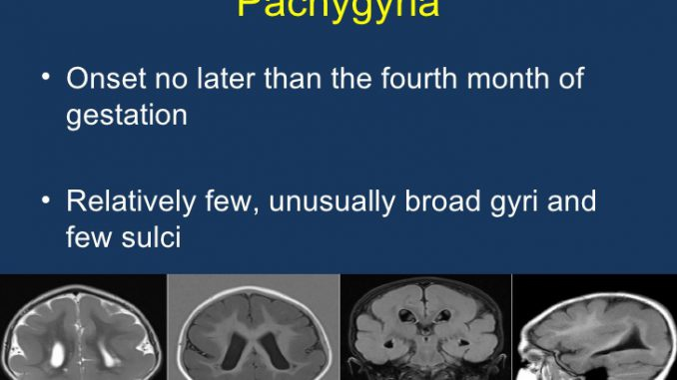
Revision 21 for ‘Lissencephaly

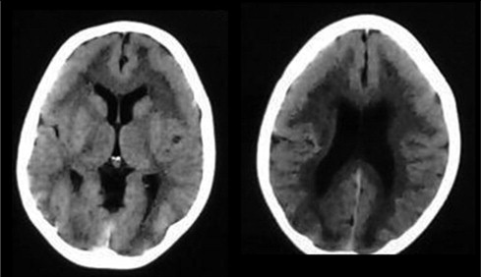
Pachygyria. CT scan shows bilateral frontal lobes ...

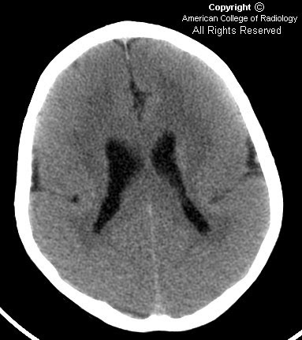
Neuroradiology On the Net: Pachygyria

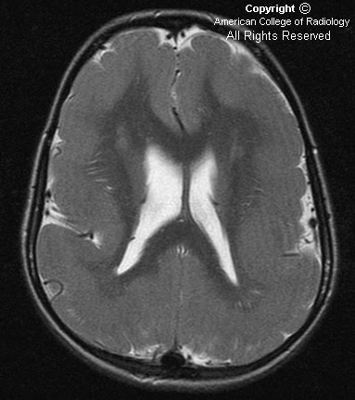
Neuroradiology On the Net: Pachygyria
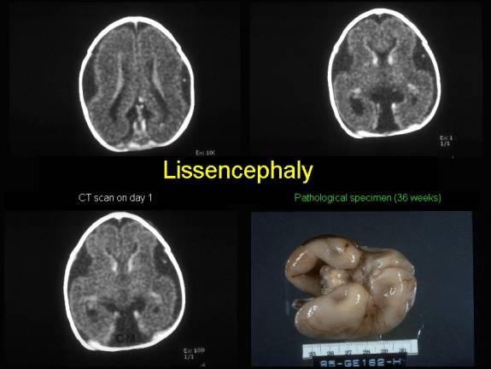
Lissencephaly Vs Normal Brain

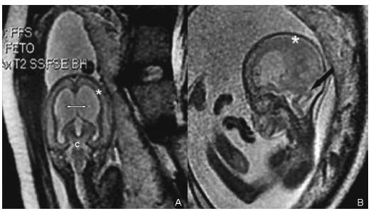
Prenatal Diagnosis of Lissencephaly Type 2 using Three ...

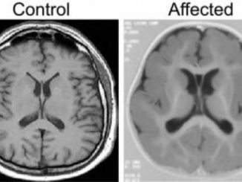
Pachygyria Mild Lissencephaly

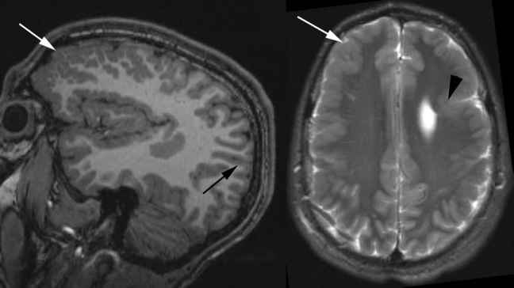
Figure 134 Epilepsy Diagnosis

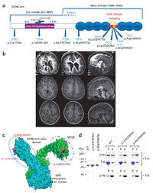
Mutations in TUBG1, DYNC1H1, KIF5C and KIF2A cause ...

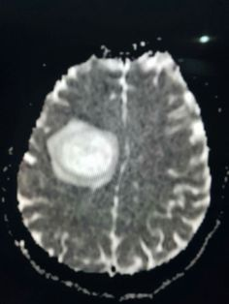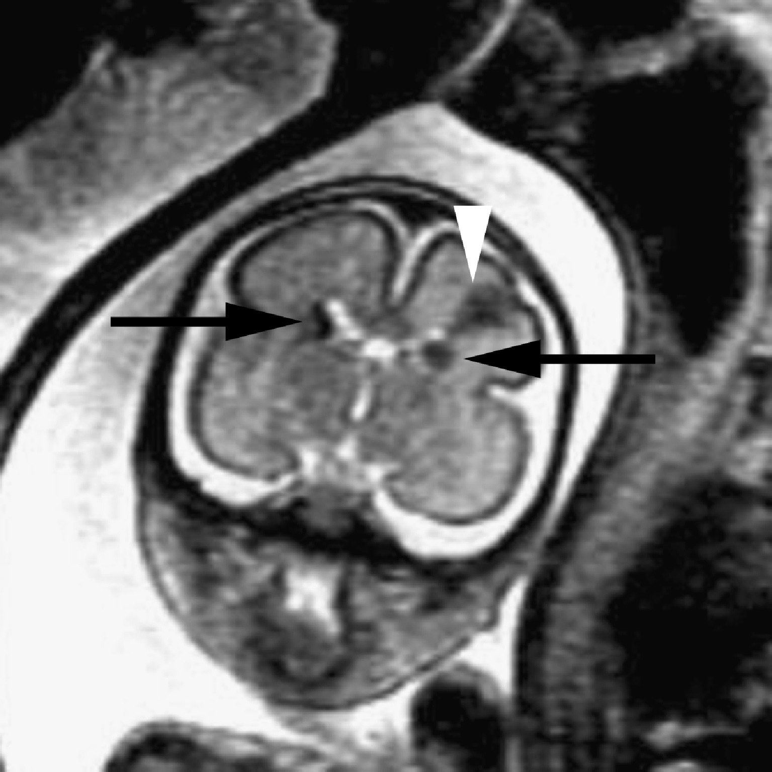
Lissencephaly Fetal Mri

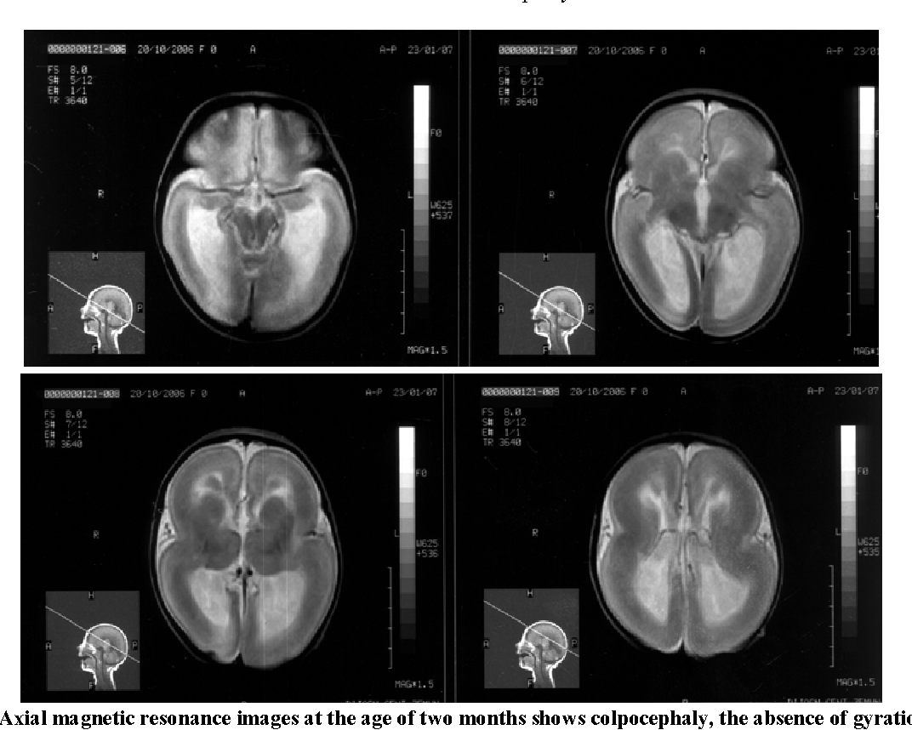
[PDF] Prenatal diagnosis of lissencephaly : A case report ...

https://line.17qq.com/articles/dpcomnccv.html

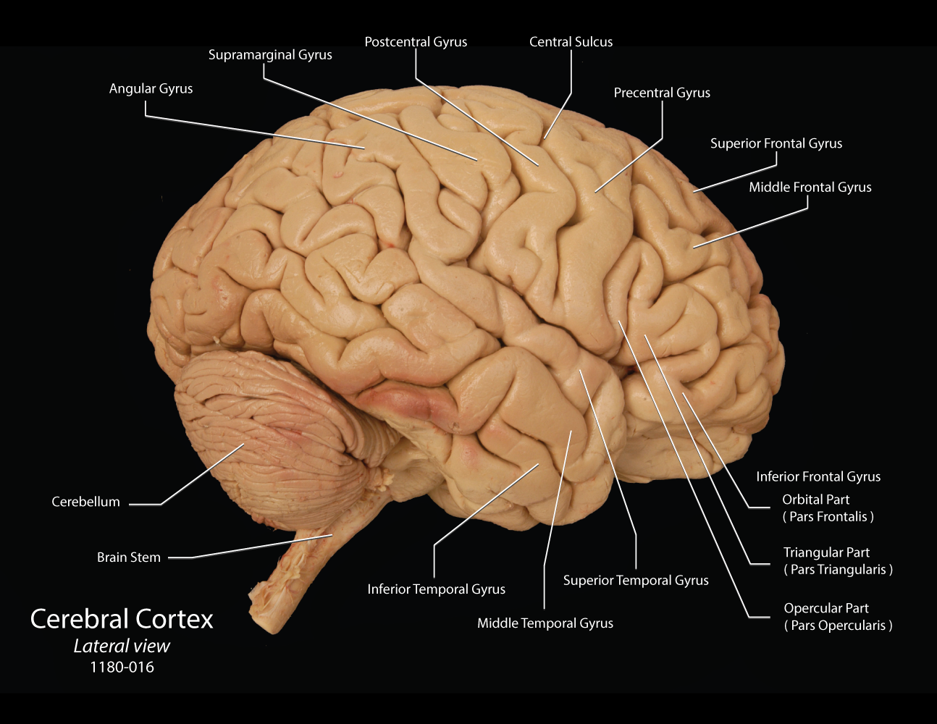
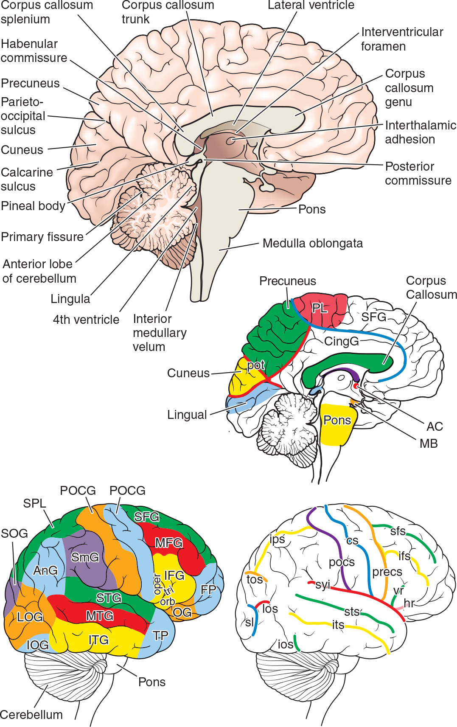
Neuromuscular The Rehabilitation Specialist's Handbook, 4e F.A. Davis PT Collection

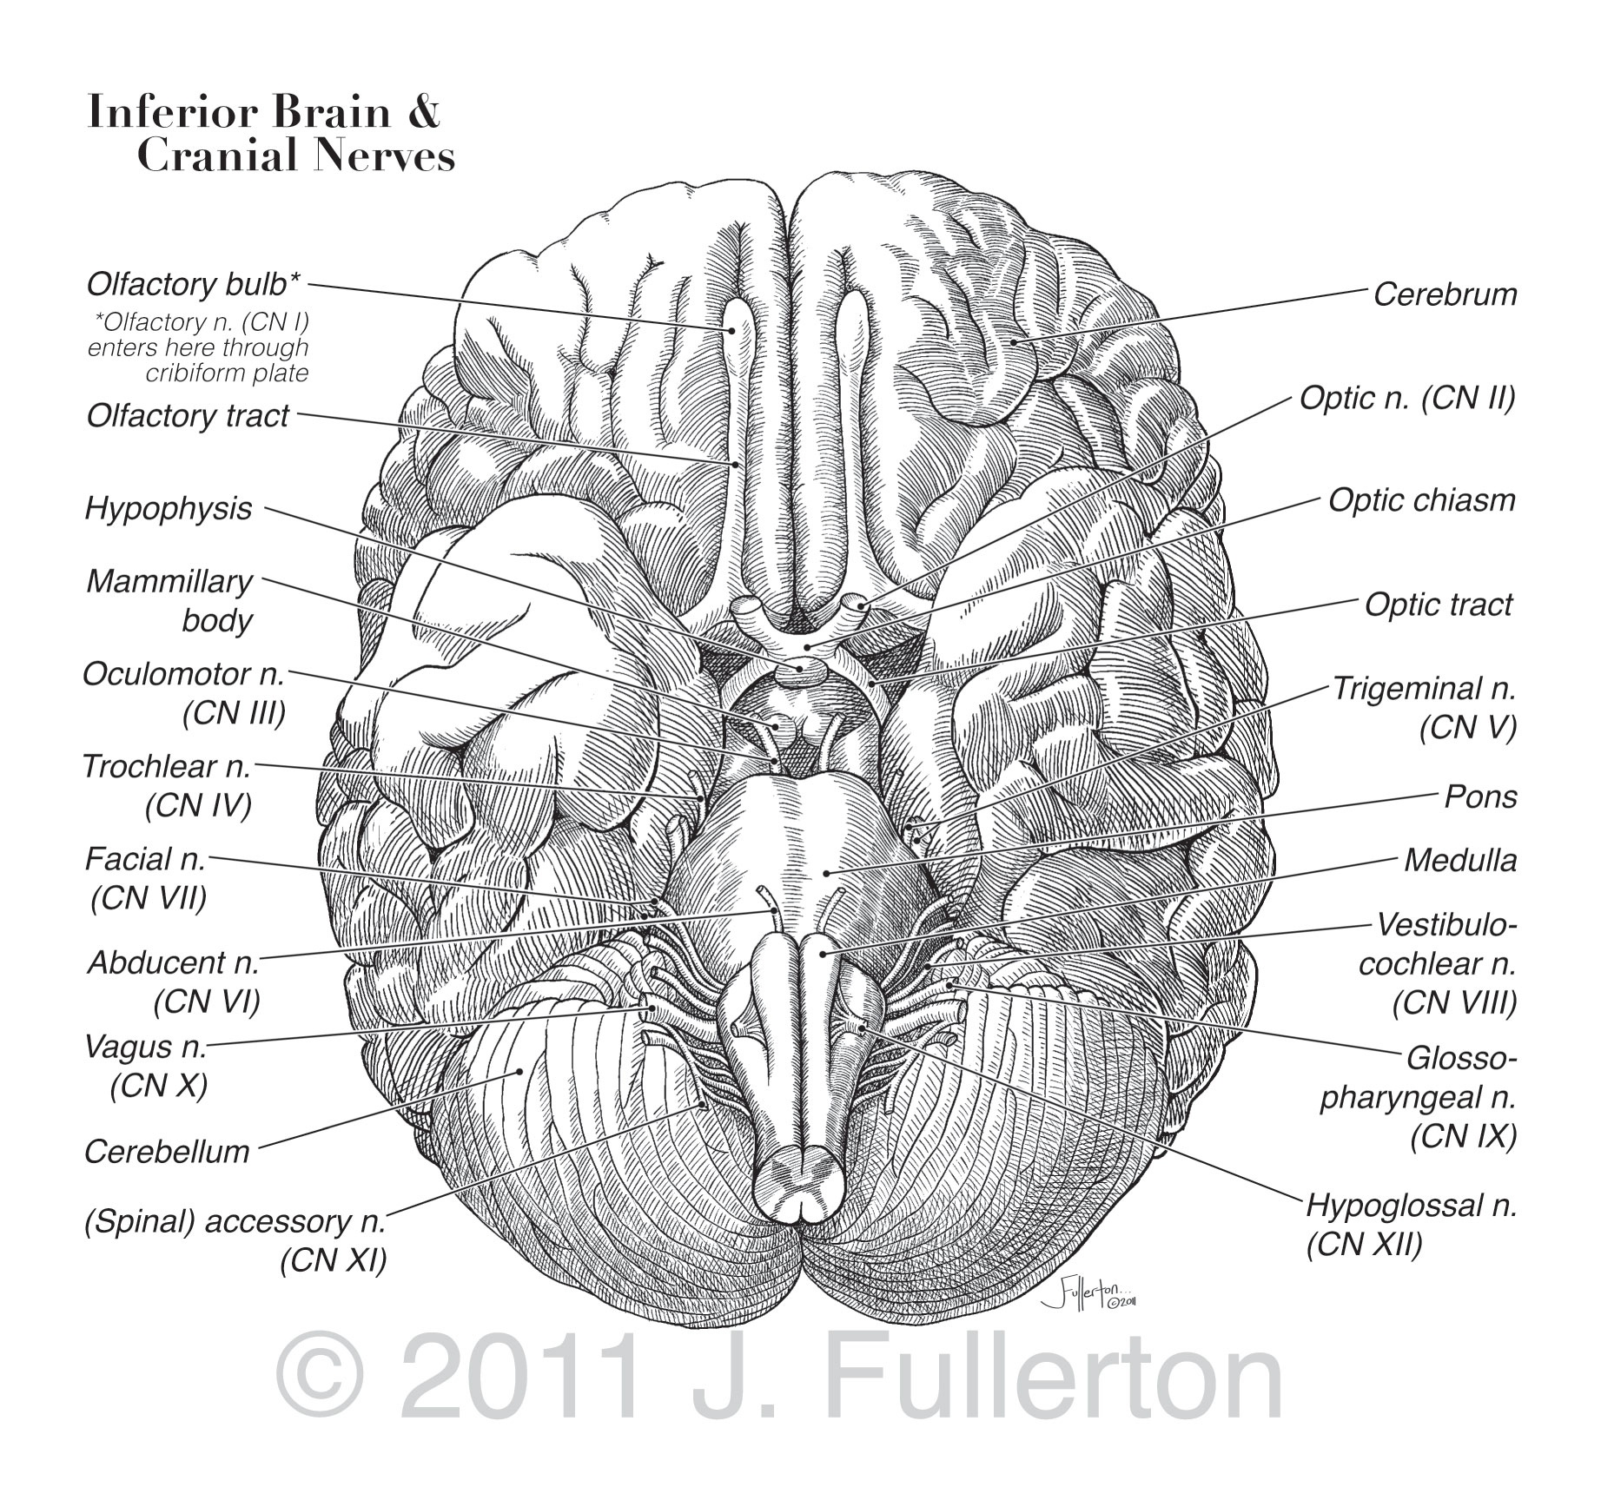
Scalpel & Pencil an education in Science & Art

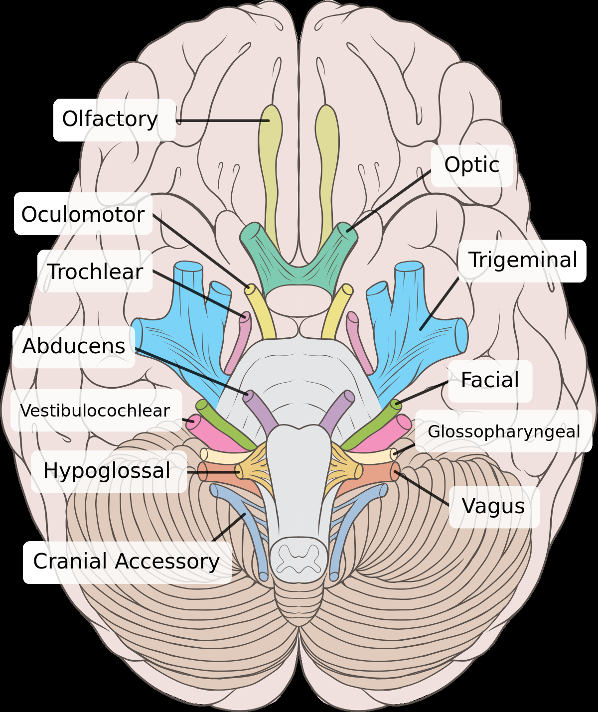
Vestibulocochlear nerve - Wikipedia

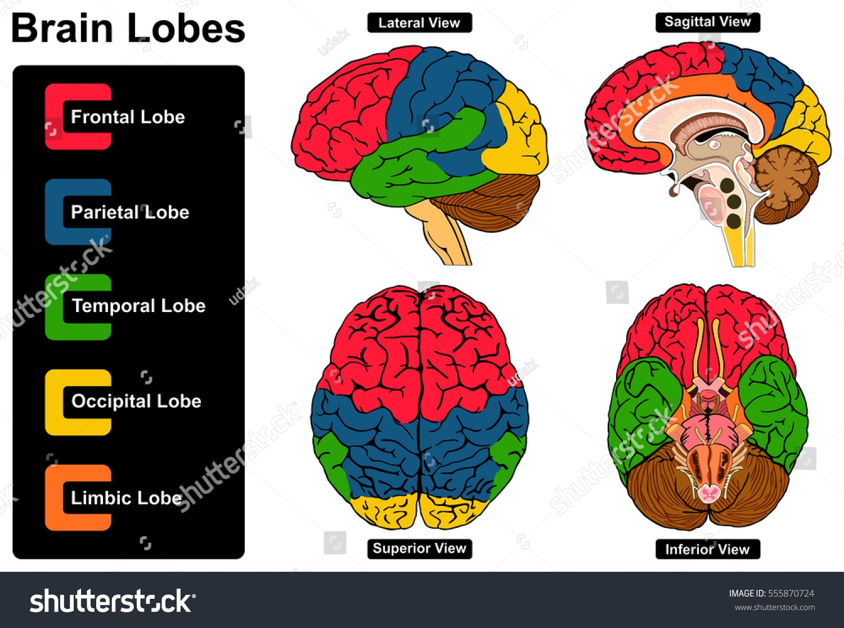
Human Brain Anatomy Set Lateral Sagittal Stock Illustration 555870724

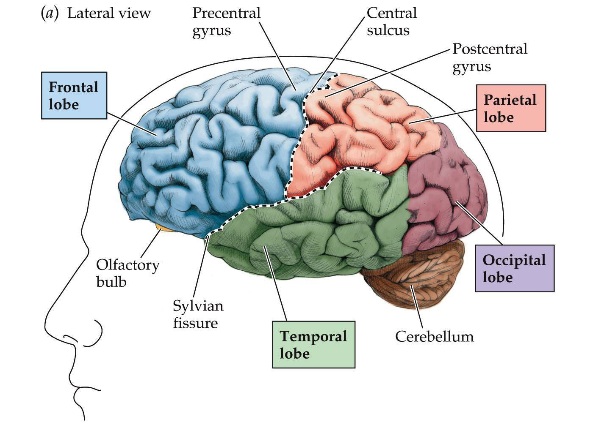
https://img.17qq.com/images/arrswhqsqrx.jpeg

